
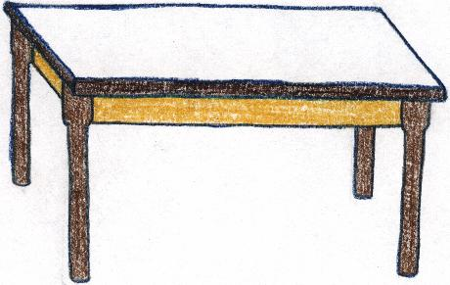
4) Question: How many table legs are there?

Addition:

Multiplication:

5) You need to buy socks for these basketball players. How many socks do you need? How many pairs of socks?

Addition:

Multiplication:

