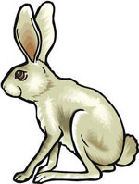
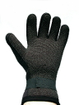
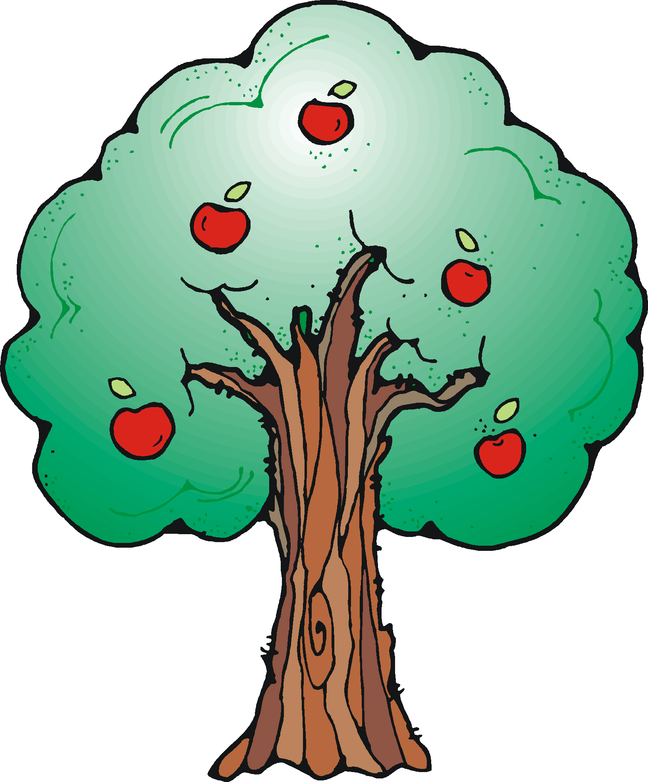
- How many ears do these bunnies have all together?

Addition;

Multiplication:

- How many fingers on these gloves?

Addition:

Multiplication:

- How many apples on the trees?

Addition:

Multiplication:

